PHASE - 5

Name: M. Siva Petchi

Nm I'd:au952821106039

Project: Environmental Monitoring

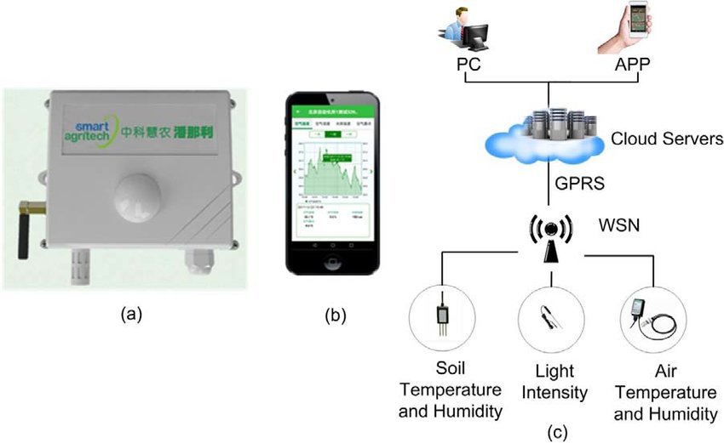

Environmental monitoring involves the systematic collection, analysis, and interpretation of data related to various aspects of the environment. Here are some additional details:

1. **Purposes**: Environmental monitoring is conducted for various purposes, including assessing the impact of human activities on the environment, tracking changes in environmental parameters, ensuring compliance with regulations, and early warning of environmental hazards.

2. **Parameters Monitored**: Parameters include air quality (e.g., pollutants like CO2 and PM2.5), water quality (e.g., pH, dissolved oxygen, pollutants), soil quality (e.g., nutrient levels, contaminants), biodiversity (e.g., species diversity and abundance), and climate variables (e.g., temperature and precipitation).

3. **Monitoring Methods**: Monitoring can be done through various methods, such as field sampling, remote sensing, sensor networks, and satellite observations. It often involves using specialized instruments and data analysis tools.

4. **Spatial and Temporal Scales**: Monitoring can be conducted at local, regional, national, or global scales and can be continuous or periodic, depending on the objectives.

5. **Data Analysis**: Collected data is analyzed to identify trends, anomalies, and potential environmental issues. Geographic Information Systems (GIS) and statistical analysis play a crucial role.

6. **Regulatory Compliance**: Many industries and activities are required to monitor their environmental impact to ensure compliance with environmental regulations.

7. **Early Warning Systems**: Environmental monitoring can be used to develop early warning systems for natural disasters like floods, droughts, and forest fires.

8. **Public Awareness**: It helps raise public awareness of environmental issues and provides data to support environmental policies and decision-making.

9. **Technology Advancements**: Advancements in technology, including the Internet of Things (IoT) and big data analytics, have revolutionized environmental monitoring.

10. **Global Initiatives**: Organizations like the United Nations and the World Health Organization promote international cooperation in environmental monitoring to address global challenges.

11. **Challenges**: Challenges include the cost of monitoring, data management, and the need for standardized protocols to ensure data quality and comparability.

12. **Environmental Impact Assessment (EIA)**: Environmental monitoring is often a part of the EIA process for new development projects to predict and mitigate potential environmental impacts.

13. **Examples**: Some common examples of environmental monitoring programs include air quality monitoring in urban areas, water quality monitoring in rivers and lakes, and wildlife tracking for conservation efforts.

Environmental monitoring is critical for understanding and addressing environmental issues, protecting ecosystems, and ensuring a sustainable future. It plays a vital role in safeguarding the health and well-being of both the natural world and human populations.

Some hardware components of environmental monitoring

Environmental monitoring systems typically consist of various hardware components, sensors, and equipment to collect data on environmental parameters. The specific components you need depend on the parameters you want to monitor. Here are some common hardware components used in environmental monitoring systems:

1. **Sensors:** These are the primary components used to measure environmental parameters. Different types of sensors are available for monitoring various aspects of the environment, such as temperature, humidity, air quality, water quality, light, radiation, and more.

2. **Data Loggers:** Data loggers are devices that record data from sensors over time. They can store and transmit data to a central system for analysis and storage. Data loggers are essential for long-term monitoring.

3. **Communication Equipment:** To transmit data from remote monitoring locations to a central server or control center, you may need communication equipment, such as modems, cellular modules, or Wi-Fi adapters.

4. **Power Supply:** Depending on the monitoring location, you may need to provide a power source, such as batteries or solar panels, to ensure continuous operation of the monitoring equipment.

5. **Weather Stations:** Weather stations combine various sensors to measure parameters like temperature, humidity, wind speed and direction, precipitation, and atmospheric pressure. They are commonly used for meteorological and environmental monitoring.

6. **Water Quality Monitoring Equipment:** This includes sensors and instruments for measuring parameters like pH, dissolved oxygen, turbidity, and chemical concentrations in water bodies.

7. **Air Quality Monitors:** These devices measure air pollutants such as particulate matter (PM2.5, PM10), carbon monoxide (CO), nitrogen dioxide (NO2), sulfur dioxide (SO2), and ozone (O3).

8. **Remote Cameras:** Cameras can be used for visual monitoring and to capture images or videos of environmental conditions in remote areas.

9. **GIS (Geographic Information System) Tools:** Geographic information systems are used to map and analyze spatial data, helping in visualizing and understanding environmental changes over time.

10. **Telemetry Systems:** For remote and automated data transmission, telemetry systems are used to relay data to a central database or monitoring center.

11. **Environmental Enclosures:** These protect sensors and monitoring equipment from harsh weather conditions, especially in outdoor installations.

12. **Datalogger Software:** Software programs for configuring data loggers, collecting and storing data, and analyzing the information gathered.

13. **Alarms and Alerting Systems:** These can be integrated to send notifications or alerts when certain environmental parameters go beyond specified thresholds.

14. **Centralized Data Servers:** These servers store and manage the collected environmental data, making it accessible for analysis, reporting, and decision-making.

The specific combination of hardware components and sensors will depend on your monitoring objectives and the environmental parameters you want to track. Environmental monitoring can range from simple setups to complex systems that utilize advanced technology and data analysis methods.

Program:

import Adafruit_DHT

# Set the sensor type and pin

sensor = Adafruit_DHT.DHT22

pin = 4 # GPIO pin where the sensor is connected

while True:

# Try to read data from the sensor

humidity, temperature = Adafruit_DHT.read_retry(sensor, pin)

if humidity is not None and temperature is not None:

# Print the data to the console

print(f'Temperature: {temperature:.2f}°C, Humidity: {humidity:.2f}%')

else:

print('Failed to retrieve data from the sensor. Check the connection.')

# Optionally, you can add code for data storage, logging, and more sensors as needed.